***Feasibility Study***

***Situation in which the Project Exists***: This proposal is for the data communication and business operations for a new privately owned Art’s Gallery. The approved funding will be sufficient to pay for the development. This proposal is pending acceptance from the gallery’s benefactors and owners.

***Network Scope***: The proposed network is designed to serve the privately owned Art’s Gallery. The Art’s Gallery is made up of the physical gallery location, as well as a storage warehouse. The network will be used for accessing and managing information related to the gallery’s art exhibits and pieces.

***Objectives of the Network***. The Art’s Gallery requires that data related to art exhibits and pieces can be publicly shown to guests though a website. This information should come from a database with several other data that will not be shown to guests, such as exhibit maintenance. Server administrators must be able to manage the network from a centralized device. Employees stationed at the gallery must be able to edit information related to exhibits, and be able to manage events, such as biddings. Warehouse employees must be able to add additional exhibits into the database when one is welcomed.

***Intended Users***.  The primary users of the network will be the Art’s Gallery employees, including server administrators, gallery employees, and warehouse employees. Additionally, guest users will be allowed to view selected data related to gallery exhibits and pieces, and gallery contributors will be allowed to access function related to contributing exhibits and pieces to the gallery, as well as bidders, which will be allowed to access functions related to bidding. Guests are secondary users, as they will be able to see information related to exhibits, but not interact with the network beyond that.

***Design Assumptions***. This design assumes the following:

* The Art’s Gallery will construct its gallery with the network for its use case
* There will be 99.9% uptime on internet access to selected parts of the network
* There is a firewall that separates information meant for employee and information meant for non-employees
* There is a firewall that separates functions meant for bidders and contributors
* Guest access is limited to viewing select data regarding the gallery pieces
* There is a firewall that separates the warehouse information from non-employees

***NETWORK NEEDS ANALYSIS***

***Data Types***.  Data types that will be used by the network are account information, profiles, web pages. Majority of data will be text with some image and video. No live video/audio data will be used.

***Data Sources***. Data will be created on employee client devices, and network will be managed at the server side. Data will be managed using Windows 10 as the operating system, and the Art Gallery inventory will be managed by inventory application. Servers will run server applications for management.

***Numbers of Users and Priority Levels***.  The users of the network will be administrators, gallery employees, warehouse employees, contributors, bidders, and guest users. The maximum estimated number of users on the network at any given time is 30: 2 administrators, 7 gallery employees, 7 warehouse employees, and 14 clients connected from the internet of any combination of contributors, bidders and guests.

Priority falls to the server administration first, followed by employee traffic, and non-employee clients last.

***Transmission Speed Requirements***. The network’s transmission speed should be prioritized at the end-stations first, followed by off-site clients. An estimated 300 Mbps at the end-stations and 100Mbps for off-site clients will support needed performance.

***Load Variation Estimates***. Estimated peak of traffic volume will be during bidding periods, which occur during the 15th of every even month, between 1 pm to 3 pm. Average highest traffic volume occurs during the weekends between 12 pm to 4 pm. Average minimal traffic occurs at closing time through the weekday.

It is estimated that the average required throughput on the LAN during work hours will be 100 Mbps. The estimated peak traffic load will be 200 Mbps.

***Storage Requirements***. Storage requirements will store data for website hosting, and database. 1TB of storage space will be adequate to hold all data on the server. Maximum estimated server-side storage per user is about 15 GB, and the network operation system will be 6 GB. Each employee PC will have a storage capacity of 250 GB.

***Reliability Requirements***. In keeping with user expectations and industry standards, the LAN is expected to operate at 99.9% uptime and an undiscovered error rate of .001%.

***Security Requirements***. A firewall will be used so unauthorized users will be restricted from accessing sensitive data.  Part of the security will be Bidder accounts and passwords that will give limited access.  There will be different access capabilities for network managers and users. Guest users will have full access to view our guest website for guest specific information.

***Existing Network***. There is no network.

Top Level Diagram

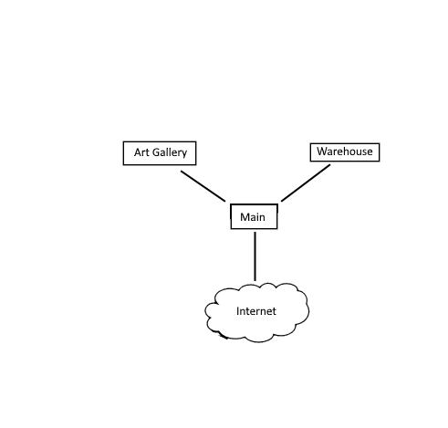

Main Server Diagram

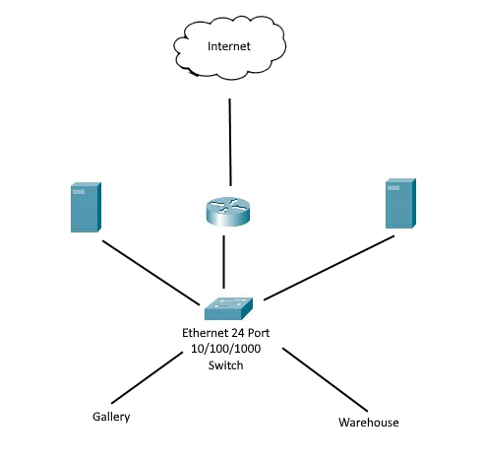

Art Gallery Diagram

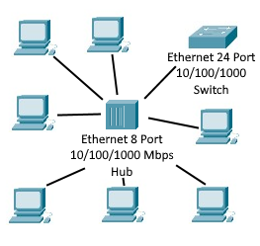

Warehouse Diagram

